Top of Form


ANEKA:

Aneka is the product of Manjarasoft.

Aneka is used for developing, deploying and managing cloud capplications.

Aneka can be integrated with existing cloud technologies.

Aneka includes extensible set of APIs associated with programming models like MapReduce.

These APIs supports different types of cloud models like private, public, hybrid cloud.

Aneka framework:

Anekas is a software platform for developing cloud computing applications.

In Aneka cloud applications are executed.

Aneka is a pure PaaS solution for cloud computing.

Aneka is a cloud middleware product.

Anekas can be deployed on a network of computers, a multicore server, datacenters, virtual cloud infrastructures, or a mixture of these.

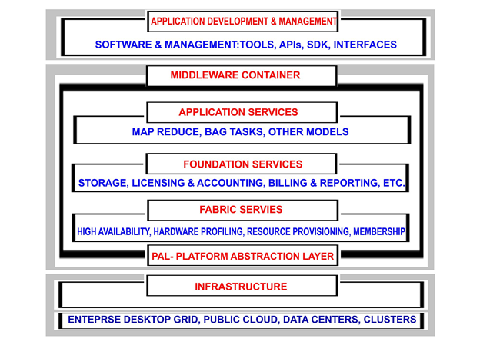
Aneka framework overview

Aneka container can be classified into three major categories:
- Fabric Services
- Foundation Services
- Application Services
1. Fabric services:
Fabric Services define the lowest level of the software stack representing the Aneka Container. They provide access to the resource-provisioning subsystem and to the monitoring facilities implemented in Aneka.

2. Foundation services:
Fabric Services are fundamental services of the Aneka Cloud and define the basic infrastructure management features of the system. Foundation Services are related to the logical management of the distributed system built on top of the infrastructure and provide supporting services for the execution of distributed applications.

3. Application services:
Application Services manage the execution of applications and constitute a layer that differentiates according to the specific programming model used for developing distributed applications on top of Aneka.

